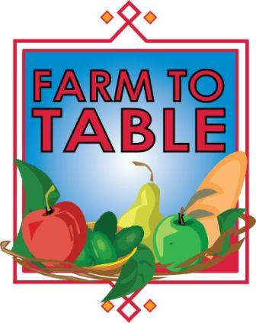

Corporate Fruit Bowl Sign Up Form

Farm to Table PA ©, a program of American HealthCare Group, will deliver a bowl of fresh fruit to your office on a regularly scheduled date, stipulated in the detailed order form below.

When you receive the delivered basket, please sign off on our delivery sheet so that we know you accepted the quantities ordered. We will bill you for the cost of the fruit basket bi-monthly and you can pay by check or credit card for your order.

Please let us know if you have any questions or changes to your order or billing inquiries by emailing Erin at EHart@american-healthcare.net by calling 412-563-7807.

In the event that the delivery day is scheduled on a national holiday, the delivery will be made on the next business day.

Thank you for your business and we look forward to providing you with fresh, healthy fruit.
Company: |  |  |  |  |  |  | Contact Name:
Billing Address: |  |  |  |  |  |  | City/State/Zip:
Delivery Address: |  |  |  |  |  |  | City/State/Zip:
Phone: |  |  |  | Fax: |  |  | Email:
Quantity: | 50  $60 |  | 75  $90 | 100  $120 | 150  $180 | Drop location:
Frequency: | Weekly Bi-Monthly Monthly
Payment Method: | *Check via Invoice Credit Card: Automatic  *Checks payable to: American Health Fairs, 1910 Cochran Road, Manor Oak One, 405, Pittsburgh, PA 15220
Credit Card Type: |  | Visa MasterCard American Express
Card Number:
Exp Date and Security Code
Name on card:
Address where the credit card bill is sent:

Do you have a receptacle? Yes______ No______
**If needed, first bowl is included, each additional bowl is $10.00.

Time building can be accessed:__________________ Person receiving fruit:____________________________

