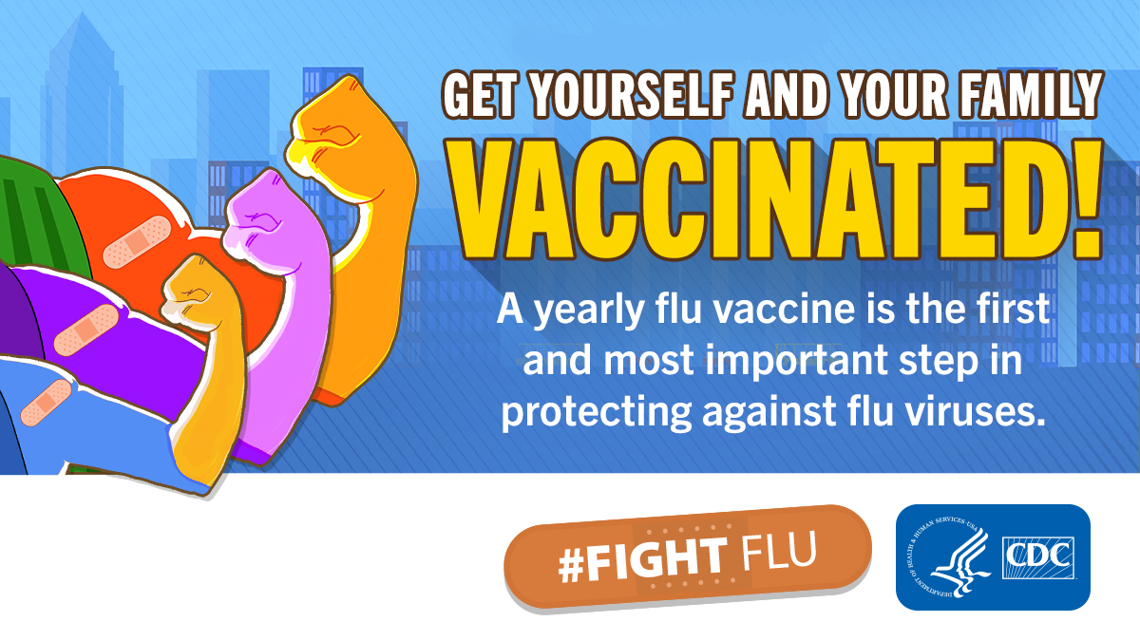

Location:
Date:
Time:

Flu, Pneumonia, Shingles and more available
We will verify your health insurance coverage

Location:
Date:
Time:

Flu, Pneumonia, Shingles and more available
We will verify your health insurance coverage

