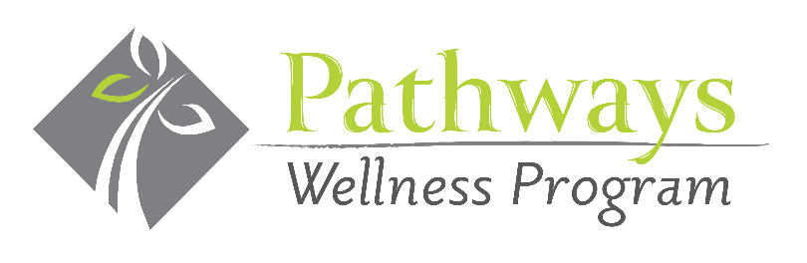

Payment & Delivery Information
Company: |  |  |  |  |  | Contact Name:
Phone:
Email:
Billing Address: |  |  |  |  |  | City/State/Zip:
Delivery Address: |  |  |  |  |  | City/State/Zip:
Quantity: |  | 50  $75 | 75  $105 | 100  $140 | 150  $200 |  | 200  $260
Frequency: |  | Weekly Bi-Monthly Monthly
Payment Method: |  | Check via Invoice Credit Card  2% charge on credit card payments  Checks payable to: Pathways Wellness Program  733 Washington Road, Suite 102 Pittsburgh, PA 15228
Credit Card Type: | Visa MasterCard American Express
Card Number:
Exp. Date:
Security Code:
Name on card:
Credit Card Address:
Time building can be accessed
Person receiving fruit
Pathways Wellness Program, LLC will deliver a bowl of fresh fruit on a regularly scheduled date, stipulated in the detailed order form below. When you receive the delivered basket, please sign off on our delivery sheet so that we know you accepted the quantities ordered. We will bill you for the cost of the fruit basket bi-monthly and you can pay by check or credit card for your order.
In the event that the delivery day is scheduled on a national holiday, the delivery will be made on the next business day. Please let us know if you have any questions or changes to your order or billing inquiries!

Thank you for your business and we look forward to providing you with fresh, healthy fruit.
Do you have a bowl to hold the fruit? Yes______ No______ **If needed, first bowl $20.00.
Email Completed form to: Jemma@PathwaysWellnessProgram.com Questions? Call 412-563-7802

