Client Clinic Prep Guide
At Pathways Wellness Program, we want to make your onsite clinic a success! To help your team have a smooth and seamless experience, we’ve prepared a helpful checklist and sample employee communications.
These tools guide you through everything from preparing the space and promoting the clinic to managing day-of activities, ensuring your employees know what to expect and your clinic runs efficiently.
Before the Clinic
Communications:
- Send an email to employees (see sample language below)
Signage & Promotion:
- Place signs in common areas (lobby, break rooms, near elevators) to remind employees of the clinic.
- Post any digital announcements in internal newsletters or intranet.
Space Preparation:
- Reserve a room or area with tables and chairs
- Make sure the space has adequate lighting

What Pathways Needs From You Day-of Event
- Designated clinic space ready with tables and chairs.
- Internal contact available to assist employees and answer questions.

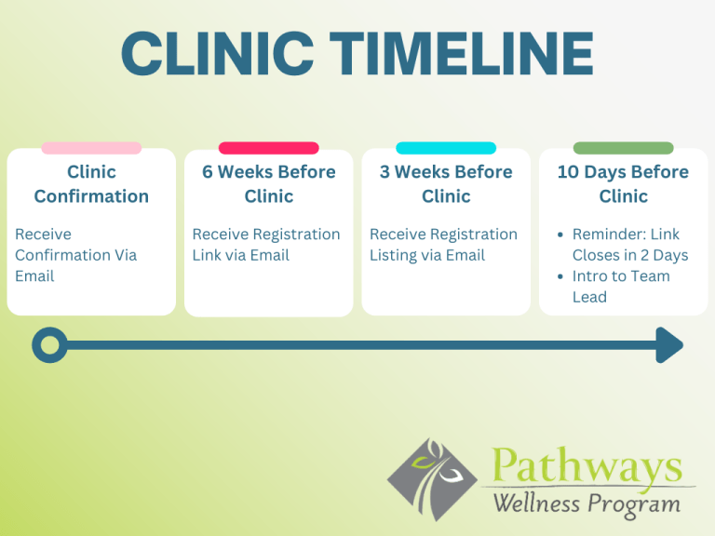
What you can expect from us:
- 6 weeks before clinic: Registration Link (if registering online)
- 3 weeks before clinic: A registration listing of those who are signed up
- 10 days before clinic: Final reminder email! Link closes in 2 days.
Introduction to the Team Lead who will be onsite at your event.

Sample Employee Email TemplateS

First: Choose your Registration Option: Online registration or Walk-ins only or Physical sign-up list
Next: Customize to meet your group’s needs:
Date/Time/Location (you can copy this from the Clinic Confirmation Email)

1️⃣ Online Registration Email — Link Closes 8 Days Before
Subject: Pathways Wellness Program Coming Onsite – Reserve Your Spot Today!
Body:
Hello [Employee Name],
Pathways Wellness Program will be onsite to offer an onsite immunization clinic – right here at work!
📅 Date: [Insert date]
🕒 Time: [Insert time]
📍 Location: [Insert location]
💉 Vaccines Available: [Insert vaccine list here – e.g., Flu, Tdap, Shingles, Hepatitis B, etc.]
👉 Register online here: [Insert registration link]
Registration closes 8 days before the clinic, so don’t wait — sign up now to reserve your spot!
Walk-ins are always welcome for flu shots.
Optional: Please bring your insurance card to your appointment.
If you have questions, please contact [Internal Contact Name] at [Internal Contact Email/Phone].
We look forward to seeing you onsite!
Pathways Wellness Program Team
Wellness made easy, right where you work.

2️⃣ Walk-In Only Email — No Registration Required
Subject: Pathways Wellness Program Onsite – Walk Right In for Your Immunization!
Body:
Hello [Employee Name],
Pathways Wellness Program will be onsite to offer an onsite immunization clinic – right here at work!
No registration is needed — just stop by during the clinic hours below!
📅 Date: [Insert date]
🕒 Time: [Insert time]
📍 Location: [Insert location]
💉 Vaccines Available: [Insert vaccine list here]
Walk-ins are welcome and encouraged — especially for flu shots!
Optional: Please bring your insurance card to your appointment.
Questions? Contact [Internal Contact Name] at [Internal Contact Email/Phone].
Stay healthy and protected this season!
Pathways Wellness Program Team
Wellness made easy, right where you work.

3️⃣ Physical Sign-Up List Email — Sign Up at Work
Subject: Pathways Wellness Program Onsite – Sign Up on the Office List
Body:
Hello [Employee Name],
Pathways Wellness Program will be onsite to offer an onsite immunization clinic – right here at work!
📅 Date: [Insert date]
🕒 Time: [Insert time]
📍 Location: [Insert location]
💉 Vaccines Available: [Insert vaccine list here]
👉 Register: Please add your name to the sign-up sheet located at [Insert location of physical sign-up sheet] to reserve your time slot.
Optional: Please bring your insurance card to your appointment.
If you have any questions, reach out to [Internal Contact Name] at [Internal Contact Email/Phone].
We look forward to seeing you at the clinic!
Pathways Wellness Program Team
Wellness made easy, right where you work.



IMMUNIZATION Sign Up Sheet

Time | Name | Phone | Company Insurance? | Flu | cOvid-19 (pfizer)

